Characterization of rotor losses in High Speed Permanent Magnet Synchronous Machines

A. Caunes, N. Takorabet
Université de Lorraine GREEN
F-54506 Vandoeuvre les Nancy France
antomne.caunes3@etu.univ-lorraine.fr
noureddine.takorabet@univ-lorraine.fr
S. Chaithongsuk
Rajamangala University of technology Suvarnabhumi – Nonthaburi, Thailand
sisuda_ch@yahoo.com
L. Duranton
Artus, Meggitt Group
49241 Avrillé France
laurent.duranton@meggitt.com

Abstract—This paper presents a synthesis of the analysis and modelling of the rotor losses in high speed permanent magnets motors. Three types of losses are due to eddy currents in the conductive parts of the rotor. The analysis includes their characterization and the setup of a numerical model using finite element methods. The analysis is applied on a high speed PM motor for avionic application.
Keywords— Permanent magnet motors, rotor losses, modelling, efficiency, motor design Introduction

Introduction
Permanent Magnet motors are used in many applications for their compactness and high power density. In particular, aerospace applications need to reduce the mass of embarked components. Therefore increasing the speed of electrical machines allows increasing the power density. On the other hand, in order to improve the efficiency of permanent magnet synchronous machines (PMSM), it is crucial to understand which design parameter has an influence on the losses. Especially for high-speed machines, the rotor losses can be quite high and, in some extreme cases, the losses can lead to the damage of the machine caused by the demagnetization of the magnets. For this reason, analytical and numerical models have been proposed for modelling the different losses in the rotors of permanent magnet synchronous motors.
The losses in the magnets have different origins which can be grouped in three categories[1]:
- Slotting effect losses: caused by the interaction between the stator slots-teeth alternation facing the magnets
- Armature reaction losses: caused by phase belt harmonics of the electric loading
- Switching harmonic losses: caused but the high order harmonics of the currents due to PWM power supply
This paper presents different origins and highlights these phenomena. Adapted methods for their evaluation are developed and discussed. A basic generic model of a high speed PM synchronous motor is used to illustrate these methods.

Slotting effect losses
The alternating pattern of slots and teeth in front of the magnets causes a local variation of flux density inside the magnets. This phenomenon causes losses in the magnets even at no-load operation. A standard way to compute these losses consists in simulating the no-load operation of a PM machine with a time stepping finite element model (TS-FEM) during a certain number of electric periods, the rotor being moving at the rated speed. This method supposes simulation of at least 10 periods so that the electric steady state is reached. Then the losses can be determined on the last period with:
$P_{slotting}=\int_{Magnet}{\left[\frac{1}{T}\int_{O}^{T}{σ{\left(\frac{∂a_{z}}{dt}\right)}^{2}dt}\right]dv}$ (1)
where $σ$ is the electric conductivity of the magnets and $a_{z}$ is the axial component of the magnetic vector potential (mvp).
An alternate way consists in computing the field distribution in the magnets with multi-static approach with magnetostatic FEM model over on slot period. The values of the mvp $a_{z,i}(θ)$ on the elements in the domains representing magnets, are stored once and the losses can be estimated by:
$P_{s1}=\sum_{i=1}^{n_{e}}{\left[\frac{ω}{θ_{slot}}\int_{O}^{θ_{slot}}{σ{\left(\frac{∂a_{z,i}}{dθ}\right)}^{2}dθ}\right]}$ (2)
where $ω$ is the rotational speed, $θ_{slot}$ is the slot pitch and $n_{e}$ is the number of elements in the magnets domain.
This technique is implemented on a PM motor by using FEMM free software and it reduces strongly CPU time while keeping good accuracy of the model. Figure 1 shows the discretization of the rotor magnets represented by dots regularly spaced inside the magnets. Loss density plots is shown on Fig. 2, which shows that this phenomenon is localized in the upper side of the magnets. The losses are higher on the side of the magnet which is the nearest to the stator teeth.
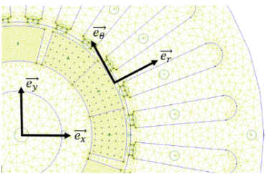
Fig. 1. Cross section of PM machine and rotor discretization
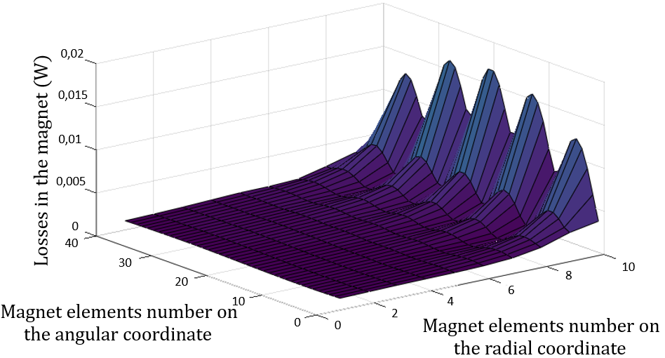
Fig. 2. Losses density inside one magnet

Harmonic reaction losses
The stator winding is not purely sinusoidal and generates reaction field with a certain amount of harmonics. Three phase machines are characterized by harmonics of order $h=6k±1$ . They generates eddy currents in the rotor with a frequency $6kf_{0}$ ($f_{0}$ being the frequency of the stator currents). Fast Fourier Transform can be used to determine the spectral component of the ampere-turns in the slots (electrical loading) and the parts that generates each harmonic separately. This technique is well describes in previous papers [2] [3]. The approach to evaluate the losses induced by the windings’ harmonics consist of three steps:
- Calculation of the ampere-turns distribution in the windings, using the connexion matrix
- Determination of the harmonics spectrum by using discrete Fourier transform on the current distributrion
- For each harmonic, the inverse of the discrete Fourier transform is used to obtain the harmonic’s ampere-turn distribution in the windings
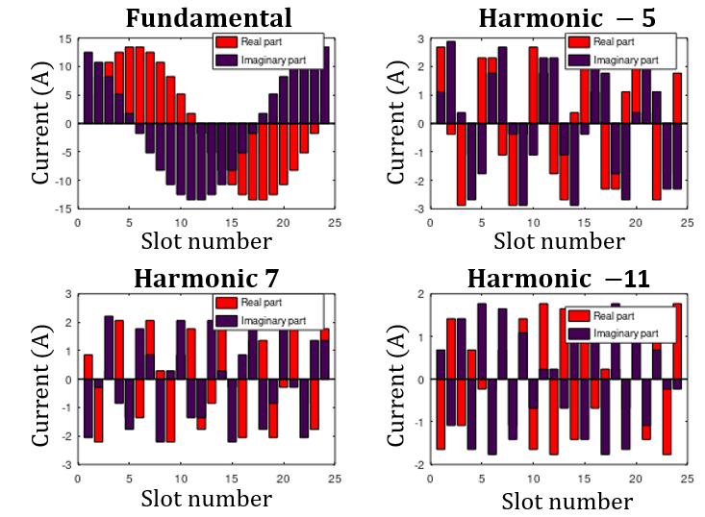
Fig. 3. Ampere-turns distribution in the slots – harmonic contents
The harmonic ampere-turn distributions are shown on Fig. 3. Under the hypothesis of piecewise constant reluctivity, the superposition principle can be adopted and losses can be determined by separate filed computation with time-harmonic FE Model. For each considered space harmonic of rank $h$ the following problem can be solved:

$∇^{2}A_{h}=0$ in the stator & air-gap (3)
$∇ . ν∇A_{h}=jσω\left(h-1\right)A_{h}$ in the rotor (4)
$J=h^{th} harmonic ampere-turns$ in the slots (5)

where $A_{h}$ is the complex representation of the $h^{th}$ space harmonic of the magnetic vector potential, $ν, σ$ are the magnetic reluctivity and the electric conductivity. The main hypothesis of this technique consists in considering that saturation is mainly due to magnet’s flux. A frozen permeability method may be used. This method allows evaluating the contribution of each winding harmonic to the losses in the rotor magnets.

Switchning harmonics losses
PWM power supplies use high frequency carrier signals. These frequencies, about several kHz, can be found in the harmonic spectrum of the input current of the motor[3]. In order to estimate their impact on the global amount of losses, it is necessary to determine the amount of eddy current losses in the magnets as a function of the frequency. This normalized characteristic can be determined by TH-FE model weighted with coefficients corresponding to the stator current harmonics. The method of evaluation of these losses, described in this paper, is based on the superposition principle. Losses in the different parts of the rotor are computed for a unitary reference current in the inductors and for various frequencies. Depending of the skin depth of currents inside the PMs ($δ=1\sqrt{πf_{h}μσ})$, and the mesh size, two approaches can be used to evaluate the eddy current losses in the magnets:
- A whole FE model that considers the magnets and solve field equations in the magnets domain.
- A boundary impedance model that suppresses the magnets and introduces small skin depth boundary condition of the border of the rotor (Fig. 4.1)
The losses caracteristics . $P(f)$ obtained by the two models are showon on Fig. 4.b. The switching frequencies losses are determined by:
$P_{s3}=\sum_{i=1}^{n_{h}}{P\left(f_{i}\right)I_{i}^{2}}$ (6)
Where $n_{h}$ is the number of considered harmonics in the spectum of the currents waveforms, $I_{i}^{}$ is the rms value of the current harmonic f frequency $f_{i}$.
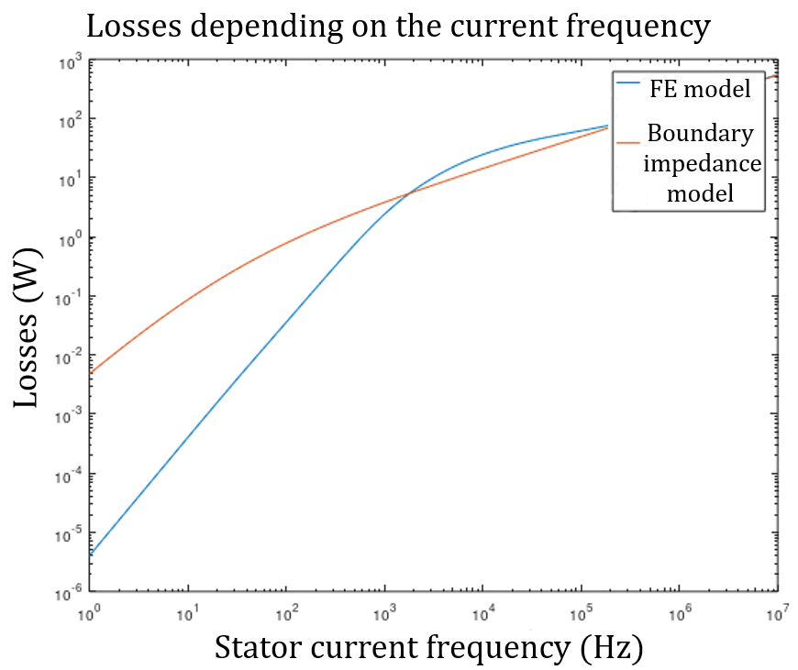
Fig. 4. Small skin depth method and results
The whole analysis and discussion of results will be given in the full paper.

Conclusion
This paper gives some computational techniques that allows to determine rotor losses in PMSMs with reduced CPU times and numerical resources. The proposed methods have been tested and validated. They can be implemented in a whole design model, which can be used in an optimization process. The advantage of such models consists in more accuracy and less CPU time which is suitable of optimization.

References
[1] R. Lateb, Modélisation des machines asynchones et synchrones à aimants avec prise en compte des harmoniques d’espace et de temps: application à la propulsion marine par POD. PhD thesis, INPL, 2006.
[2] B. Laporte, S. Mézani, N. Takorabet, A Discreet Fourier Transform Based Method to compute steady state operation of induction motors Using Complex finite Elements, IEEE Compumag'03, July 13-17, 2003, New York USA
[3] S. Chaithongsuk, N. Takorabet, S. Kreuawan, « Reduction of Eddy-Current Losses in Fractional-Slot Concentrated-Winding Synchronous PM Motors », IEEE Transactions on Magnetics, vol. 51, nº 3, March 2015.

978-1-7281-1560-3/19/$31.00 ©2019 IEEE

