Increase the visibility of your company by
sponsoring the conference
ISEF’2019
(https://isef2019.sciencesconf.org/)

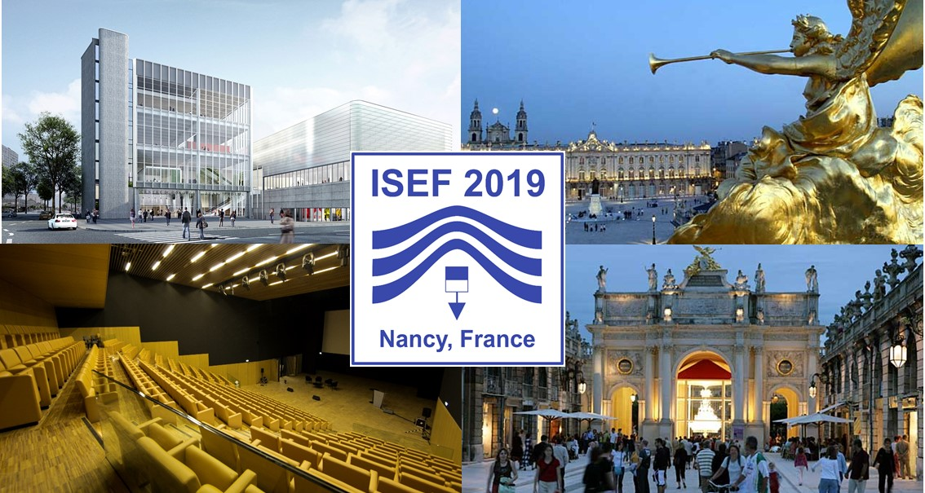
PARTNERSHIP & SPONSORSHIP

Within the framework of the conference, we offer you the opportunity to meet your partners and customers in the best conditions on the space of exhibition.

ISEF is one of the famous international conferences in the field of applied electromagnetism and electrical engineering; it concerns a large international community of researchers from universities, specialized institutes and the industrial community. In 2015, this conference took place in Spain (Valencia) in 2017, and in Poland (Lodz). Each time, it attracts more than 250 participants from more than 20 different nationalities.

The 2019 edition will take place in Nancy downtown, in the new Convention Center (Center Prouvé) close to all facilities of the city. (www.grandnancy-congresetevenements.com).

This exhibition will allow to promote your company and to present your latest products to an exceptional forum of recognized specialists in the field of electromagnetism, electrical engineering and mechatronics, including young graduates to be hired.
This scientific event will give the opportunity to become acquainted with the latest innovations offered by state-of-the-art products available on the market.

Several types of participation and sponsorship in the conference are proposed, feel free to contact us for any proposal.

Awaiting the pleasure to welcome you to Nancy, we remain.

The Organizing Committee

EXHIBITION

A special hall will be reserved for the exhibition booths of the sponsors. This space will be located in the heart of the conference rooms. You can contact us to discuss the offer that will meet the needs of your business. The rates for the various services are summarized below.

The exhibition will be organized as a “table-top exhibit” only, using table of 1.4 m x 0.70 m.
Two chairs will be provided. It will be possible for the exhibitor to have enough space for totem displays; decoration on tables or signalization (name of company) to be provided by exhibitor.

The price of the stand includes the following services:
- the use of the stand during the duration of the exhibition and assembly and disassembly periods; coordination services of congress during the assembly and disassembly periods of the stands and during the duration of exposure;
- surveillance of public areas of the exhibition, excluding stands areas that remain under the exhibitors responsability;
- cleaning services of the alleys and public areas
- fixed number of exhibitor badges
- announcement of your participation on the conference website and proceedings (logo).

BOOTH from 6m²

Price HT (VAT excluded) per module, including :
- 1 exhibitor badge - access to coffee breaks and lunches only
- 1 conference badge –full access

The basis booth equipment includes :
- 1 furniture assembly : 1 table - 2 chairs

SPONSORING

PLATINIUM Sponsor
- 1 dedicated stand in a privileged location, booth of 6m²
- Your banner (kakemono or roll-up) in the amphitheater (to be provided by the partner)
- One page advertisement in the final conference program
- Insert of company’s document (4 pages) in the participants bag (to be provided by the partner)
- 2 conference badges –full access
- 2 exhibitor badges (visitors)
- Your logo:
  - On the conference web site with link to your company website
  - In the proceedings of the conference
  - On the bag given to participants and exhibitors

GOLD Sponsor
- 1 dedicated stand in a privileged location, booth of 6m²
- half page advertisement in the final conference program
- Insert of company’s document (4 pages) in the participants bag (to be provided by the partner)
- 1 conference badge –full access
- 1 exhibitor badge (visitor)
- Your logo:
  - On the conference web site with link to your company website
  - In the proceedings of the conference
  - On the bag given to participants and exhibitors

SILVER Sponsor
- 1 stand, booth of 6m²
- Insert of company’s document (4 pages) in the participants bag (to be provided by the partner)
- 1 conference badge –full access
- Your logo:
  - On the conference web site with link to your company website
  - In the proceedings of the conference
  - On the bag given to participants and exhibitors

BRONZE Sponsor
- Your logo:
  - On the conference web site with link to your company website
  - In the proceedings of the conference

PUBLICITY SPONSORSHIP

Support of the badges
- Exclusive, badges and lanyard with the logo of your company

quantities may slightly changed according to the registration volume

Support of the USB
- USB Key with the logo of your company
- The proceedings, given to all the participants, will be charged on the keys

quantities may slightly changed according to the registration volume

Support of poster price
- Price given to the best poster

Insert in congress bags
- Pens – provided by the company
- Notebooks - provided by the company
- Insert of promotional documents (4 pages max) - provided by the company
- Other …

Advertising insert in the conference proceedings
Optimum visibility on the congress through advertising in conference proceedings delivered on-site to all delegates. Advertising provided by the company. (half page)

Support of coffee-break, lunch, opera cocktail, gala dinner cocktail
To become partner of one of the symposium catering- Please contact our secretary.

Support Events of social program
To become partner of one of the evenings social program- please contact our secretary

CONTACT

For any information or reservation please contact :

Prof. Babak Nahidmobarakeh
Université de Lorraine – GREEN
2, avenue de la forêt de Haye
Email : babak.nahid@univ-lorraine.fr

Dr Gaëtan Didier
Université de Lorraine – GREEN
2, avenue de la forêt de Haye
Email : gaetan.didier@univ-lorraine.fr

